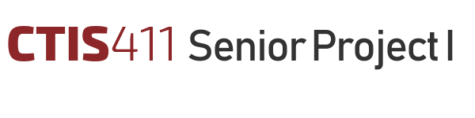

Software Design Description
CULTURATI
Team 22

Ayesha Nizam, 22001260
Göktuğ Şenkoyun, 22103191
Talal Salman Zafeer, 22001483
Tarık Ebubekir Koca, 22103032
Enes Memigüven, 22002674

Bilkent University
Department of Information Systems and Technologies

08.01.2025
Change History
File Name | Document Type | Deliverable | Version | Submission Date
Deliverable_4.docx | MS Word 2013 | 4 | 0.1 | -
Team22_SDD_FR1 | MS Word 2013 | 4 | 1 | 08.01.2025

Project Team
Name, Surname | Student Id Number | e-mail
Ayesha  Nizam | 22001260 | ayesha.nizam@ug.bilkent.edu.tr
Göktuğ  Şenkoyun | 22103191 | goktug.senkoyun@ug.bilkent.edu.tr
Talal Salman  Zafeer | 22001483 | talalsalmanzafeer@gmail.com
Tarık Ebubekir  Koca | 22103032 | tebubekirkoca03@gmail.com
Enes  Memigüven | 22002674 | enes54657@gmail.com

Project Details
Project Name | CULTURATI
Software Name | CULTURATI
Company Name | Horizon Europe RIA
Academic Advisor | Neşe Şahin Özçelik
Github URL | https://github.com/AyeshaNizam-5/CULTURATI
WEB page

Individual Contributions Overview
Name, Surname | Summary of Contributions to the SDD Document
Ayesha  Nizam | Main responsible of the Document Formatting  Contributed to Executive Summary, Scope and Analysis Model and Planning
Göktuğ  Şenkoyun | Main responsible of the Document Formatting  Contributed to High level Design, Low Level Design and Discussion.

Executive Summary

This Software Design Document (SDD) details the architecture and design of the CULTURATI CMS, focusing on development over three increments. The first increment establishes core functionalities for admin, including user authentication, account management. The second increment adds workflows for data entry operators and content creators, enabling advanced content management. The third increment finalizes the CMS with editor dashboards, customizable themes, multilingual support, and mobile application prototypes. The system employs a Model-View-Controller (MVC) architecture within a monolithic structure, balancing performance, security, and maintainability. The Model layer manages data with PostgreSQL, the View layer uses React.js for responsive frontend design, and the Controller layer handles routing and business logic with Express.js. This structure supports performance optimizations, secure role-based access, modular maintainability, and efficient recovery processes. Key technologies include JavaScript for development, PostgreSQL for relational data management, React.js, and Node.js with Express.js for the backend. Deployment and cloud services rely on AWS Amplify, AWS Lambda, and AWS RDS for scalability and efficiency. The SDD incorporates diagrams for both high- and low-level design. High-level diagrams include Block, EER, Communication, and Deployment diagrams to define system architecture and deployment. Low-level design includes UML Class, Activity, and Sequence diagrams to detail component interactions and processes for the first increment. The chosen architecture ensures rapid development, clear organization, and efficient testing and deployment while meeting critical non-functional requirements. Though monolithic, it provides a strong foundation for the CMS while addressing scalability and operational constraints effectively.

Page Number
Executive Summary i
Table of Contents ii
1 Scope 1
2 Analysis Model & Planning 3
2.1.1 FR-01: User Authentication 5
2.1.2 Account Management 6
2.1.3 Institution Management 7
2.1.4 FR-04: First-Time User Password Setup 9
2.1.5 Content Creation by Content Creators 9
2.1.6 Managing Categories, Difficuty Levels, and Types by Content Creators 11
2.1.7 FR-07: Managing Content by Content Creators 13
2.1.8 FR-08: Content Review and Approval by Editors 14
2.1.9 FR-09: Managing Institution Information by Data Entry Operators 15
2.1.10 FR-10: API Development for Data Sharing 17
2.1.11 FR-11: User Account and Settings Management 19
3 High-Level (Architecture) Design 28
4 Low Level Design 45
1.Authentication System (UC-01, UC-22) 46
First-Time Password Setup Pseudo Code 49
5 Discussions 60
5.1 Limitations and Constraints 60
5.2 Health and Safety Issues 61
5.3 Legal Issues 61
5.4 Economic Issues and Constraints 61
5.5 Sustainability 61
5.6 Ethical Issues 61
5.7 Multidisciplinary Collaboration 61
6 References 62

Table of Contents
List of Tables
Page Number
The list of tables (if any) should be automatically created by MS Word.

List of Figures
Page Number
The list of figures (if any) should be automatically created by MS Word.

Abbreviations

NPV | Net Present Value
SDD | Software Design Description
SRS | Software Requirements Specification
WBS | Work Breakdown Structure

Scope
The Software Design Document (SDD) for the CULTURATI CMS provides a comprehensive roadmap for the design and development of the system. The document encompasses detailed explanations, diagrams, and methodologies to guide the development team in achieving the system’s objectives. It begins with an overview of the scope of the system, detailing the goals and functionality that the software must provide. It then proceeds to outline the analysis model, which includes an in-depth look at various functional requirements such as user authentication, account management, institution management, content creation, content review, and approval workflows. The analysis model covers the specifics of use cases, use case diagram, functional requirements, non-functional requirements and the software development environment.
Following the analysis model, the document presents the high-level architecture design. The chosen architectural style is justified based on its alignment with the non-functional requirements of the system, such as scalability, security, and performance. In this section, the system’s overall architecture is described in detail, supported by a block diagram that illustrates the system's components and their interactions. This diagram provides a visual representation of the software architecture, which includes the frontend, backend, and database layers. The document also presents the logical view, showcasing how the system is structured at a conceptual level, including the data flow between various system components.
The Entity-Relationship (EER) diagram is also provided as part of the high-level design, detailing the database schema for the system. The diagram reflects the relationships between various entities such as users, content creators, data entry operators, and editors. This EER diagram is from the original version found in the SRS.
In the process view, the document includes a detailed explanation of how different use cases in the first increment are realized. The use case realization is demonstrated through UML communication diagrams, which illustrate how the system's components interact during specific use cases such as user authentication or content creation. This section helps developers understand the flow of information between system components and how the overall system will behave during specific operations.
The physical view is represented through a UML deployment diagram, which outlines how the system will be deployed in a real-world environment. This diagram shows the physical infrastructure of the system, including servers, databases, cloud services, and other hardware components. It highlights how the software components will be deployed across multiple environments, such as development, staging, and production.
In the low-level design section, the document focuses on the first increment use cases, providing pseudocode for each relevant process. For instance, pseudocode is provided for the first-time password setup process, along with explanations of each step involved. UML activity, sequence, and class diagrams are included to further illustrate the design decisions. These diagrams describe the interactions and flow of processes at a granular level, ensuring a clear understanding of how each component functions.
The document concludes with a discussion of the design quality, addressing how each non-functional requirement, such as scalability, security, and performance, is met through the design decisions. Additionally, it outlines the verification and validation methods that will be employed to ensure that the system design is robust, secure, and meets the expected performance benchmarks. These methods include load testing, security audits, and code reviews, among others. This section ensures that the system will meet both functional and non-functional goals throughout its development and after deployment.

Analysis Model & Planning
- Functional Requirements
Given below is the Use Case diagram for the CULTURATI Content Management System. Referring to the use cases and use case ids, we will do the following:
- For the 1st increment, we will implement the following use cases
  - UC-01 Authenticate User
  - UC-22 Set up password for first time login
  - UC-05 Create new user account
  - UC-03 Create Institution
  - UC-02: Manage Institution
  - UC-02.1: Manage users assgined to Institution
  - UC-02.2: Edit Institution
  - UC-02.3: Delete Institution
  - UC-02.4: View All Institutions
  - UC-04: Manage User Account
  - UC-04.1: Assign Role(s) to User
  - UC-04.2: Edit user account
  - UC-04.3: Delete User Account
- For the 2nd increment, we will implement the following use cases
  - UC-07: Create Content
  - UC-07.2: Create Content for route
  - UC-07.1: Create Content for game
  - UC-09 Manage Content
  - UC-09.1: Edit Content
  - UC-09.2: Delete Content
  - UC-09.3: Export Content to PDF/CSV
  - UC-13: Create New Category/Difficulty Level/Type
  - UC-06: Manage Category/Difficulty Level/Type
  - UC-06.1: Delete Category/Difficulty Level/Type
  - UC-06.2: Edit Existing Category/Difficulty Level/Type
  - UC-06.3: View Existing Category/Difficulty Level/Type
  - UC-08: Preview Content
  - UC-16: Add Institution Details
  - UC-17: Edit Institution Details
  - UC-18: Delete Institution Details
  - UC-21: View Institution Details
- For the 3rd increment, we will implement the following use cases
  - UC-15 Manage Content for Publishing
  - UC-15.1: Reject Content
  - UC-15.2: Approve Content
  - UC-14: View All Content
  - UC-10 Edit User Account Information
  - UC-11 Change Dashboard Theme
  - UC-12 Change System Language
  - UC-19: Access Visitor-Specific Content via API
  - UC-20: Filter Content by Category, Difficulty, and Type

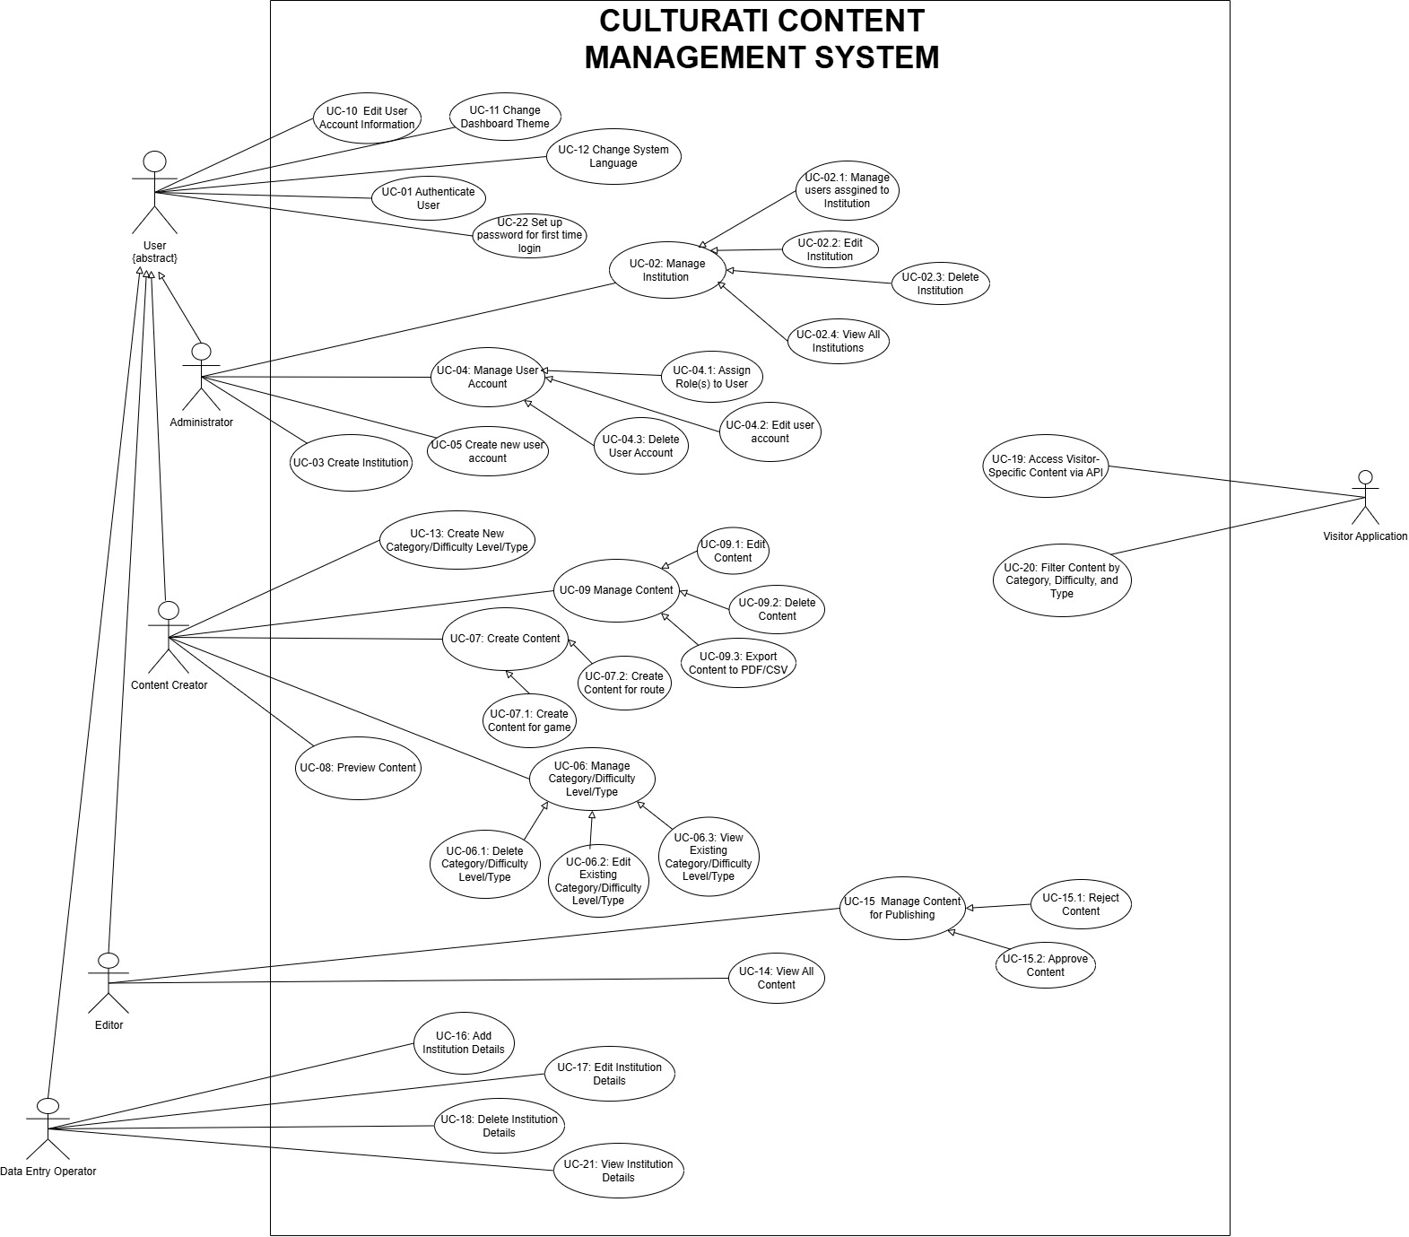

FR-01: User Authentication
- The system shall require the following inputs for a user to log in:
  - Username and password entered into their respective fields.
  - Captcha security code to verify the user is human.
- The user shall click the "Login" button to submit their credentials.
- The system shall validate the entered credentials and captcha:
  - If the username, password, and captcha are correct, access shall be granted to the user’s account.
  - If any input is incorrect:
    - An error message shall display, explaining the issue.
    - The user shall have up to three attempts to log in. After the third failed attempt, the account shall be locked
    - If the account is locked, the user shall receive a notification via email with instructions to unlock the account.

Account Management
Create User Account
- Admins shall access the admin dashboard of the CMS website to manage user accounts.
- On the dashboard, the admin shall click the "Create User Account" button to open the account creation page.
- The account creation page shall require the following inputs:
  - Mandatory fields:
    - FirstName
    - Last Name
    - Username
    - Password
    - Confirm Password
    - Email Address
  - The admin shall select the user’s role using a radio button for one of the following:
    - Content Creator
    - Editor
    - Data Entry Operator
  - The admin shall select the institution the user will belong to using a drop-down list of existing institutions.
- After entering the required information, the admin shall click the "Create Account" button to complete the process.
- Upon successful account creation:
  - The new user shall receive an email notification with:
    - Their temporary credentials.
    - A link to log in to their account.
  - The system shall record the creation of the user account in an audit log.
Manage User Accounts
- The system shall allow admins to view a list of all users from the admin dashboard.
- Admins shall only be able to manage the accounts they created.
  - Actions allowed for admins include:
    - Deleting a user account.
    - Changing a user’s role.
    - Assigning multiple roles to a single user.
    - Editing user information, such as name, email, or username.
- To perform an action, the admin shall:
  - Select a user from the list.
  - Click the corresponding action button (e.g., "Edit," "Delete").
  - Confirm the action in a pop-up dialog, where applicable.
Assigning Multiple Roles
- When editing a user account, the admin shall select additional roles for the user by:
  - Clicking on the "Edit User Roles" button.
  - Selecting one or more roles (Content Creator, Editor, or Data Entry Operator) using checkboxes.
  - Clicking the "Save Changes" button to finalize the role assignments.
- The system shall update the user’s permissions based on their new role(s).

Institution Management
Create Institution
- Admins shall have the ability to create new institutions from the admin dashboard by clicking the "Create Institution" button.
  - The system shall display an institution creation page where the admin inputs:
    - Institution name.
    - Institution code.
    - Uploads the institution logo and image by clicking the "Browse" button and selecting files from the local device.
    - Selects the type of institution from a drop-down menu. Available types include:
- Museum.
- Gallery.
- Castle.
- University.
- Garden.
- Historic Town Center.
  - The admin shall click the "Save Institution" button to create the institution.
Manage Institution
- After creating an institution, the system shall allow the admin to assign existing users (editors, content creators, and data entry operators) to the institution.
  - The admin shall click the "Assign Users" button, which opens a new screen.
  - On this screen, the admin shall input the username and email of the user being assigned to the institution.
  - Once the user is assigned, the system shall notify them via email that they have been added to a new institution.
- The system shall allow admins to display all institutions within the CMS.
  - Admins shall only manage institutions they have created.
  - Management capabilities include:
    - Editing institution details such as name, code, logo, image, and type.
    - Assigning or removing users (editors, content creators, data entry operators) from the institution.
    - Deleting the institution if it is no longer needed.

- When deleting an institution, the system shall prompt the admin for confirmation before permanently removing the institution and its associated data.

FR-04: First-Time User Password Setup
- When a user (editor, content creator, or data entry operator) accesses their account for the first time through the link received via email, the system shall redirect them to the "Password Setup" page.
  - The system shall display input fields for the following:
    - New Password.
    - Confirm Password.
- The system shall enforce the following password requirements:
  - The password must be at least 8 characters long.
  - The password must contain at least one uppercase letter.
  - The password must include at least one symbol (e.g., @, #, $).
  - The password must not match the username.
- The user shall click the "Set Password" button to finalize the password setup.
- If the entered passwords do not meet the requirements or do not match:
  - The system shall display an error message specifying the issue (e.g., "Password does not meet complexity requirements" or "Passwords do not match").
  - The user shall be prompted to re-enter the password.
- Once the password is successfully set, the system shall redirect the user to the login page.
- The user shall log in using their new credentials following the process outlined in FR-01: User Authentication.

Content Creation by Content Creators
- On a new page, the content creator shall select the type of content they want to create using a radio button:
  - Game Content
  - Route Content
- After selecting the content type, the content creator shall choose the following attributes from existing lists:
  - Category: The system shall display a drop-down menu containing existing categories such as art, painting, sculptures, nature, clay, and science.
  - Difficulty Level: The system shall display a drop-down menu with existing difficulty levels such as beginner, professional, or specific age ranges (e.g., 10-15 years).
  - Type of Content: The system shall display a drop-down menu with existing types such as individual, group, or family.
- Based on the selected content type, the following fields shall be provided for input:
  - For Game Content:
    - Question: A mandatory text field for the content creator to enter the question.
    - Answer Options:
      - The system shall require at least two answer options (mandatory).
      - The question type shall be multiple-choice (MCQ).
    - Correct Answer: A mandatory field for specifying the correct answer.
    - Location: A mandatory field to specify the location the question belongs to (e.g., "an object in the museum at the third floor").
    - Penalty Score:
      - A mandatory drop-down menu for selecting penalty scores (25%, 50%, or 70%), used in the visitor-side application to calculate total scores and deduct for incorrect attempts.
    - Optional Fields for Additional Information:
      - Sound File: A field to insert an audio file, with a placeholder value (e.g., "Insert sound file").
      - Image File: A field to insert an image file, with a placeholder value (e.g., "Insert image file").
      - Video File: A field to insert a video file, with a placeholder value (e.g., "Insert video file").
      - External Link: A text field for inserting a hyperlink, leading to an external browser tab (e.g., an article).
    - Clues: Optional fields to provide additional hints:
      - Text, sound, or video file.
  - For Route Content:
    - Description: A mandatory text area for entering a detailed paragraph about the route.
    - Location: A mandatory field with the link to location for the object/place the route content is being provided.
    - Optional Fields for Additional Information:
      - Sound File: A field to insert an audio file, with a placeholder value (e.g., "Insert sound file").
      - A field to insert an image file, with a placeholder value (e.g., "Insert image file").
      - A field to insert a video file, with a placeholder value (e.g., "Insert video file").
      - External Link: A text field for inserting a hyperlink, leading to an external browser tab (e.g., an article).
- At the end of the form, the system shall provide two buttons:
  - Preview: Clicking this button shall display a pop-up screen showing how the content will appear to visitors.
  - Save: Clicking this button shall validate all mandatory fields.
- If mandatory fields are missing, the system shall display appropriate error messages and highlight the missing fields.
- If validation passes, the new content shall be stored in the system and sent to the editor’s review queue as per FR-08: Content Approval by Editors.

Managing Categories, Difficuty Levels, and Types by Content Creators
- From the dashboard, the content creator shall have the option to create a new category, difficulty level, or type by clicking on Create Field button.
  - The system shall redirect the content creator to a page where they input the following details:
    - Name: The name of the new category, difficulty level, or type.
    - Description: A brief description of the purpose or details of the field.
    - Image: An option to upload an image by clicking the "Browse" button and selecting a file from their local device.
  - After filling in the details, the content creator shall click the "Save" button to add the new field to the respective list.
- The newly created field (category, difficulty level, or type) shall be added to the list of existing fields, which will be available for selection when creating content.
- The system shall allow content creators to manage only the categories, difficulty levels, or types they have created.
  - The system shall provide a "Manage Custom Fields" page displaying a list of all fields created by the content creator.
  - For each field, the system shall provide options to:
    - Edit:
      - The content creator shall click the "Edit" button, which opens a form pre-filled with the existing name, description, and image.
      - The content creator shall update the desired fields and click "Save Changes" to update the field.
    - Delete:
      - The content creator shall click the "Delete" button to remove the field from the list.
      - The system shall display a confirmation dialog before permanently deleting the field.
- If a content creator attempts to delete a field currently associated with existing content:
  - The system shall display a warning message indicating that the field cannot be deleted until its associations are removed.

FR-07: Managing Content by Content Creators
- Content creators shall have the ability to manage the content they create, including editing, deleting, or printing/exporting it.
- The system shall allow content creators to view all content within their institution, regardless of who created it, while restricting management actions to only the content they created.
- To edit content:
  - The content creator shall click the "Edit" button next to the desired content item.
  - The system shall display the content editing page pre-filled with the existing data.
  - The content creator shall update the following fields as applicable:
    - Text fields (e.g., question, description).
    - Attributes such as category, difficulty level, or type by selecting from existing options.
    - Replace or remove additional attachments, such as sound files, images, or videos.
  - The content creator shall click the "Save Changes" button to update the content.
  - The system shall validate the changes and save them in the database.
- To delete content:
  - The content creator shall click the "Delete" button next to the desired content item.
  - The system shall display a confirmation dialog before permanently deleting the content.
  - If confirmed, the system shall remove the content from the database and update the content list.
- To print or export content:
  - The content creator shall select one or more content items from the institution's content list by checking the corresponding boxes.
  - The system shall provide options to:
    - Export the selected content as a PDF file.
    - Export the selected content as a CSV file.
  - The content creator shall click the "Download" or "Print" button.
  - The system shall generate the selected export format with the following information:
    - Content title.
    - Attributes (e.g., category, difficulty level, type).
    - Detailed content (e.g., questions, answers, descriptions, attachments).
  - The system shall provide a link to download the file or send the file to the connected printer.
- The system shall ensure content visibility and management restrictions as follows:
  - Content creators can view all content within their institution.
  - Content creators can only edit, delete, or export content they have created.

FR-08: Content Review and Approval by Editors
- When a new content item is created by a content creator, the system shall notify all editors assigned to the institution for which the content is created.
  - Notifications shall be sent via:
    - Email, detailing the content title and attributes (e.g., category, difficulty level, type).
    - The editor’s dashboard, where the new content will appear in their review queue.
- Editors shall have the ability to view all content within their assigned institution, regardless of its creator or status.
- Editors shall review content by selecting it from the review queue:
  - The editor shall click the "Review" button next to the desired content item, opening the content review page.
  - The review page shall display all content details, including:
    - Attributes such as category, difficulty level, and type.
    - Content-specific data (e.g., questions, answers, descriptions).
    - Attachments such as sound files, images, and videos.
- Editors shall have the following actions for each content item:
  - Approve Content:
    - Clicking the "Approve" button shall update the content status to “Approved.”
    - Approved content shall be made available to the visitor-side application through the CMS APIs as per FR-10: API Development for Data Sharing.
  - Reject Content:
    - Clicking the "Reject" button shall update the content status to “Rejected.”
    - The editor shall provide a reason for rejection in a mandatory text field.
    - Rejected content shall be sent back to the content creator for revision.
- Editors shall not have permissions to create, edit, or delete content.
- The system shall update the status of all reviewed content and display it to the relevant users:
  - Content creators shall see the updated status (e.g., “Approved,” “Rejected,” or “Pending Review”) for their created content on their dashboard.
  - Editors shall see the updated status of all content within their institution.
- The system shall maintain an audit log of all editor actions, including approvals, rejections, and provided feedback.

FR-09: Managing Institution Information by Data Entry Operators
- Data entry operators shall add detailed information about the institutions assigned to them by the admins.
- For each assigned institution, the system shall provide a form for data entry operators to input the following mandatory fields
  - Location Code:
    - Data entry operators can manually enter the location code into a text field.
    - Alternatively, they can click the "Generate Location Code" button, which automatically generates a unique code.
  - Address: The system shall provide input fields to capture detailed address information, including:
    - Street.
    - Block.
    - Floor.
    - Area.
    - City.
    - State.
    - Country.
  - Description: A mandatory text field to describe the institution.
  - Area (m²): A mandatory numeric field to specify the total area of the institution in square meters.
  - Capacity: A mandatory numeric field to specify the maximum number of people the institution can accommodate.
  - Location in Map:
    - i. A field to input the geographic coordinates or use a map interface to pinpoint the institution’s location.
    - A field to provide a link to the location (e.g., Google Maps URL).
- The data entry operator shall click the "Save Information" button to submit the details.
- The system shall validate the input data to ensure all mandatory fields are completed and display appropriate error messages if any field is invalid or missing.
- Data entry operators shall have the ability to manage the detailed information for all institutions assigned to them:
  - Edit Information:
    - Data entry operators shall select an institution from their assigned list and click the "Edit" button.
    - The system shall display the current information in a form for updating.
    - After editing, the operator shall click the "Save Changes" button to update the information in the database.
  - Delete Information:
    - Data entry operators shall click the "Delete" button to remove specific entries they have added.
    - The system shall display a confirmation dialog before permanently deleting the entry.
- The system shall restrict data entry operators to manage only the institutions they are assigned to by the admin.
- The system shall log all actions taken by data entry operators, including additions, edits, and deletions, for auditing purposes.

FR-10: API Development for Data Sharing
- The system shall include APIs to enable seamless data sharing between the Content Management System (CMS) and the visitor application
- The APIs shall facilitate the sharing of the following data:
  - Categories: The list of available categories for games and routes.
  - Difficulty Levels: All predefined or user-defined difficulty levels.
  - Content Types: Types such as individual, group, or family.
  - Questions: Game-related questions, including options, correct answers, and penalties.
  - Routes: Route-related descriptions and additional information.
  - Institution Details: General and detailed information about institutions, such as location, capacity, and associated media (e.g., images, videos, and links).
- For each API endpoint, the system shall support:
  - Filters for Returning Specific Data:
    - The visitor application shall request data based on selected filters, including:
      - Category.
      - Difficulty level.
      - Content type.
    - The API shall return content (games or routes) that matches the selected filters.
  - Detailed Responses:
    - The API shall return all associated details for the requested content, including:
      - Attributes such as category, difficulty level, and type.
      - Multimedia attachments (e.g., images, videos, sound files, and external links).
      - Metadata such as location information for questions or routes.
- The API shall adhere to the following specifications:
  - RESTful Design: All APIs shall follow RESTful principles, enabling easy integration with the visitor application.
  - Data Format:
    - Requests and responses shall use JSON format for structured data exchange.
    - Multimedia data (e.g., images, videos) shall be shared via URLs for efficient retrieval.
  - Secure Communication: All API interactions shall occur over HTTPS to ensure data security.
- Specific API functionalities shall include:
  - Fetch Categories: Return all available categories for the visitor application.
  - Fetch Difficulty Levels: Return all available difficulty levels.
  - Fetch Content Types: Return all available content types.
  - Fetch Content by Filters:
    - Accept filter parameters (category, difficulty level, type).
    - Return matching content items (game or route) with associated media and metadata.
  - Fetch Institution Details:
    - Return detailed information about institutions, including address, location map link, and associated media.
- The system shall log all API requests and responses for debugging, monitoring, and auditing purposes.
- The system shall provide API documentation to ensure developers integrating with the visitor application can easily understand and implement API functionality

FR-11: User Account and Settings Management
- The system shall allow all users (Administrators, Content Creators, Editors, Data Entry Operators, and Visitors) to access their account settings through the settings page.
- Users shall have the ability to:
  - Update personal information, including first name, last name, email, phone, and address.
  - Change the dashboard theme, selecting from the following options:
    - Dark theme
    - Light theme
    - Custom color theme
  - Change the system language:
    - English
    - Turkish
- Upon selection of a new language, all text and system content shall dynamically update to the chosen language.[1]

- Non-Functional Requirements
Given below the non-functional requirements of CULTURATI content management system.
Usability requirements
  - The system's interface must be user-friendly, allowing an average user to complete key tasks within 2 minutes without prior training.
  - The admin panel must provide tooltips and concise error messages to guide users effectively.
Performance requirements
  - The system must retrieve and display content from the content management system (CMS) within 3 seconds under average load conditions.
  - The import process for bulk content transfer (1000+ records per side) must complete within 10 minutes for a standard dataset.
  - The system should support up to 50 simultaneous users without a noticeable performance degradation.
Software system attributes
  - Reliability: The system must provide a 95% uptime, excluding scheduled maintenance.
  - Availability: The system must recover from failures (e.g., server crashes) within 1 hour to ensure consistent availability.
  - Security:
    - All sensitive data (e.g., user credentials) must be encrypted using AES-256.
    - User roles (admin/visitor) must have strictly defined access control to prevent unauthorized actions.
  - Maintainability:
    - The system should use modular code and follow standard coding conventions to facilitate updates and bug fixes.
    - Documentation must be provided for all key modules, ensuring easy onboarding for new developers.
  - Portability: The system must support deployment on any operating system with Node.js and PostgreSQL installed.
Constraints
  - The system must comply with GDPR regulations to ensure data privacy and protection for users in Europe.
  - The project must be developed using React for the frontend and Typescript for maintainable code, as required by project guidelines.
  - The database must be compatible with PostgreSQL, as mandated by the infrastructure requirements.
Error Handling Requirements
User Errors:
  - If a user inputs incorrect data (e.g., invalid dates), the system must display a clear error message and allow re-entry.
  - Invalid data imported into the system must be logged with details of the error and skipped during processing.
System Errors:
  - If a system process fails (e.g., server timeout), the application must log the error and notify the admin via email or system alert.
  - For minor bugs (e.g., non-critical function failures), the system should log and continue operation without crashing.
Other Non-Functional Requirements
  - Data Import/Export:
    - The system must support batch import/export functionality for content (e.g., transferring 1000+ records) in formats such as CSV or JSON.
  - Import processes must validate data integrity and notify users of any invalid records.
  - Scalability: The system must be able to scale to support 200 simultaneous users with minimal infrastructure upgrades.
- Software Increments
The development of the CULTURATI CMS follows an incremental approach, with each increment building on the functionality delivered in the previous one. Below is a breakdown of the planned increments, including associated efforts:
First Increment:
For the first increment, the following will be done
- WP-5.1 Admin Dashboard Development: Develop the admin dashboard interface for managing user accounts and institutions.
- WP-5.2 Backend Development: Build backend functionalities to support the admin dashboard and database operations
- WP-5.3 Database Design and Implementation for admin user.
- WP-5.4 Integration of Admin Dashboard with Backend
- WP-5.5 Backend-Database Integration: Ensure seamless integration between backend and database to handle CRUD operations
- WP-5.6 Testing of Admin Dashboard: Conduct testing of the admin dashboard for usability, functionality, and responsiveness
- WP-5.7 Backend Testing: Perform testing to validate backend API performance, security, and functionality.
- WP-5.8 Database Testing: Test the database for data integrity, consistency, and query performance.
- WP-5.9 Final Integration Testing: Perform end-to-end testing to ensure all components—admin dashboard, backend, and database—are functioning together as expected.

Second Increment:
For the second increment, the following will be done:
- WP-6.1 Data Entry Operator Dashboard Development: Create an interface for data entry operators
- WP-6.2 Backend Development for Data Entry Operators: Implement backend functionalities to handle CRUD operations for institutional data.
- WP-6.3 Content Creator Dashboard Development: Design the content creator interface to create, categorize, and manage game and route content.
- WP-6.4 Backend Development for Content Creators: Develop backend features for managing content attributes, multimedia uploads, and database integration.
- WP-6.5 Database Design and Implementation for Data Entry Operator and Content Creator Use Cases: Extend the database schema to support these new functionalities.
- WP-6.6 Integration Testing for Data Entry Operator and Content Creator Features: Ensure seamless interaction between dashboards, backend, and database.
- WP-6.7 Testing for Data Entry Operator and Content Creator Features: Validate usability, performance, and accuracy of developed features.

Third Increment:
For the second increment, the following will be done:
- WP-7.1 Editor Dashboard Development: Design an interface for editors to review, approve, or reject content created by content creators.
- WP-7.2 Backend Development for Editor Use Cases: Implement features for content approval workflows, notifications, and status updates.
- WP-7.3 Theme and Language Support: Add features to allow users to customize themes (light, dark, or custom) and switch between English and Turkish languages.
- WP-7.4 Basic Visitor Applications for Testing: Develop simplified Android and iOS applications to verify that the CMS functions as intended for the visitor-side application.
- WP-7.5 Final Integration Testing: Conduct thorough end-to-end testing to ensure all components, including admin, data entry operator, content creator, editor features, and visitor apps, work together seamlessly.
- WP-7.6 System Optimization and Bug Fixes: Resolve any performance issues or defects identified during testing to ensure a stable release[3].

- Frameworks, Libraries, Services, Databases and APIs

The CULTURATI content management system project will integrate various tools and services incrementally based on the development timeline and project milestones. They are given in the table below.
Table 1. Technologies used for the development of CMS[3]
Category | Technology/Tool | Timeline | Description
Programming Languages | JavaScript | 1st Increment  2nd Increment  3rd Increment | Used for both frontend and backend development to ensure scalability and flexibility.
 | SQL | 1st Increment  2nd Increment  3rd Increment | For managing the relational database schema and queries.
 | JSON | 1st Increment  2nd Increment  3rd Increment | Used for API communication between frontend and backend.
 | HTML5 & CSS3 | 1st Increment  2nd Increment  3rd Increment | For building responsive and accessible user interfaces.
Frontend Framework | React.js | 1st Increment  2nd Increment  3rd Increment | Provides a modular and dynamic framework for building the user interface of the CMS and mobile prototype.
Backend Framework | Node.js | 1st Increment  2nd Increment  3rd Increment | Handles server-side logic, RESTful APIs, and interactions with the database.
 | Express.js | 1st Increment  2nd Increment  3rd Increment | Lightweight framework for routing and middleware in the CMS backend.
APIs & Libraries | Axios | 1st Increment  2nd Increment  3rd Increment | Handles API calls between frontend and backend efficiently.
 | Bcrypt | 2nd Increment | Provides secure password hashing for user authentication.
 | AWS SES | 2nd Increment | Amazon Simple Email Service (SES) handles email functionality, including bulk emails and notifications.
 | RESTful API | 2nd Increment  3rd Increment | Ensures standardized communication between the frontend and backend using JSON over HTTPS.
 | JWT | 2nd Increment  3rd Increment | JSON Web Tokens are used for secure user authentication and session management.
Database | PostgreSQL | 2nd Increment  3rd Increment | Serves as the relational database management system, ensuring data integrity and scalability.
Cloud Services | AWS Amplify | 2nd Increment  3rd Increment | Provides seamless deployment and hosting for web and mobile applications.
 | AWS Lambda | 2nd Increment  3rd Increment | Supports serverless execution of specific tasks and workflows.
 | AWS RDS | 2nd Increment  3rd Increment | Provides a scalable relational database service for CMS storage and retrieval.
Version Management | Git | 1st Increment  2nd Increment  3rd Increment | Used for source control and version management across the development tea
 | GitHub | 1st Increment  2nd Increment  3rd Increment | Hosts the project's code repository, supporting collaboration and CI/CD workflows.
Testing Tools | Vitest | 1st Increment  2nd Increment  3rd Increment | Facilitates unit and integration testing for both frontend and backend components.
 | Postman | 1st Increment  2nd Increment  3rd Increment | Used to test API endpoints during development.
Project Management | Google Sheets | 2nd Increment  3rd Increment | Manages Scrum workflows, sprints, and project tracking.
 | Zoom | 1st Increment  2nd Increment  3rd Increment | Facilitates team communication and collaboration.
 | Gantt Charts | 1st Increment | Used to visualize project milestones and deliverables.
Verification & Validation (V&V) | SonarQube | 2nd Increment  3rd Increment | Conducts static analysis to identify code quality issues and security vulnerabilities.
 | Jest/Vitest | 2nd Increment  3rd Increment | Used for unit testing frontend and backend modules to ensure functional correctness.
 | Postman | 1st Increment  2nd Increment  3rd Increment | Validates API endpoints and integration testing.
 | Apache JMeter | 2nd Increment  3rd Increment | Simulates concurrent user traffic to evaluate system performance and scalability.
 | OWASP ZAP | 3rd Increment | Identifies security vulnerabilities and ensures GDPR compliance.
Design Tools | Figma | 1st Increment  2nd Increment | Used to create UI/UX prototypes for the CMS and mobile interfaces.
Deployment Tools | Vercel | 1st Increment  2nd Increment  3rd Increment | Deploys the frontend applications with continuous delivery features.
 | AWS CLI | 2nd Increment  3rd Increment | Enables management of AWS services for the project's deployment needs.

High-Level (Architecture) Design
- Selected Architecture
- For the first increment demo CULTURATI CMS uses a Model-View-Controller (MVC) architectural pattern within a monolithic application structure.
- Architecture Components
- Model Layer
  - Handles data operations through PostgreSQL database
  - Implements business logic and data validation
  - Manages data integrity and relationships
- View Layer
  - React-based frontend components
  - Responsive user interface design
  - Client-side form validation and error handling
- Controller Layer
  - Express.js routes and controllers
  - Request handling and response formatting
  - Business logic orchestration
- Alignment with Non-Functional Requirements
- Performance Requirements
  - MVC's separation enables efficient caching strategies
  - Controller layer manages request queuing for concurrent users
  - Model layer optimizes database queries for 3-second response time
  - Batch processing capabilities support bulk data operations
- Security Requirements
  - Middleware layer implements role-based access control
  - Model layer enforces data encryption (AES-256)
  - Controller layer manages authentication and authorization
  - Clear separation prevents unauthorized access patterns
- Maintainability Requirements
  - Modular component structure facilitates updates
  - Standardized code organization across layers
  - Clear separation of concerns simplifies debugging
  - Documentation follows layer-specific patterns
- Availability Requirements
  - Simplified deployment and recovery procedures
  - Centralized error handling and logging
  - Streamlined backup and restore processes
  - Quick system state recovery capabilities

Advantages
- Development Efficiency
  - Rapid development cycles
  - Clear code organization
  - Simplified testing procedures
  - Straightforward debugging process
- Operational Benefits
  - Easy deployment process
  - Centralized monitoring
  - Simplified backup procedures
  - Efficient resource utilization
- Maintenance Advantages
  - Clear update paths
  - Simplified troubleshooting
  - Centralized configuration
  - Unified logging system
Disadvantages
- Scalability Limitations
  - Vertical scaling constraints
  - Monolithic deployment requirements
  - Single point of failure risk
  - Resource sharing overhead
- Development Challenges
  - Tight coupling potential
  - Technology stack constraints
  - Testing complexity in large features
  - Deployment coordination requirements

Impact on Development Process
- Development Phase
  - Structured development approach
  - Clear component boundaries
  - Simplified team coordination
  - Standardized testing procedures
- Testing Phase
  - Comprehensive testing capability
  - Simplified integration testing
  - Clear test scope definition
  - Efficient bug tracking
- Deployment Phase
  - Straightforward deployment process
  - Simplified version control
  - Clear rollback procedures
  - Efficient monitoring setup
This architectural choice provides a balanced approach that meets our non-functional requirements while maintaining development efficiency and system reliability. The monolithic MVC pattern, while having some scalability limitations, offers the best compromise for our current needs in 1st increment product.

- Logical View
To understand the CULTURATI CMS, given below are the block diagram EER diagram to provide the logical view of the product.

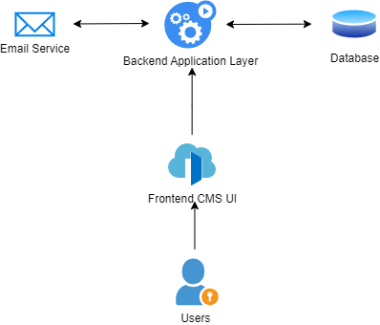
Figure 1. Simplified Architecture Block Diagram

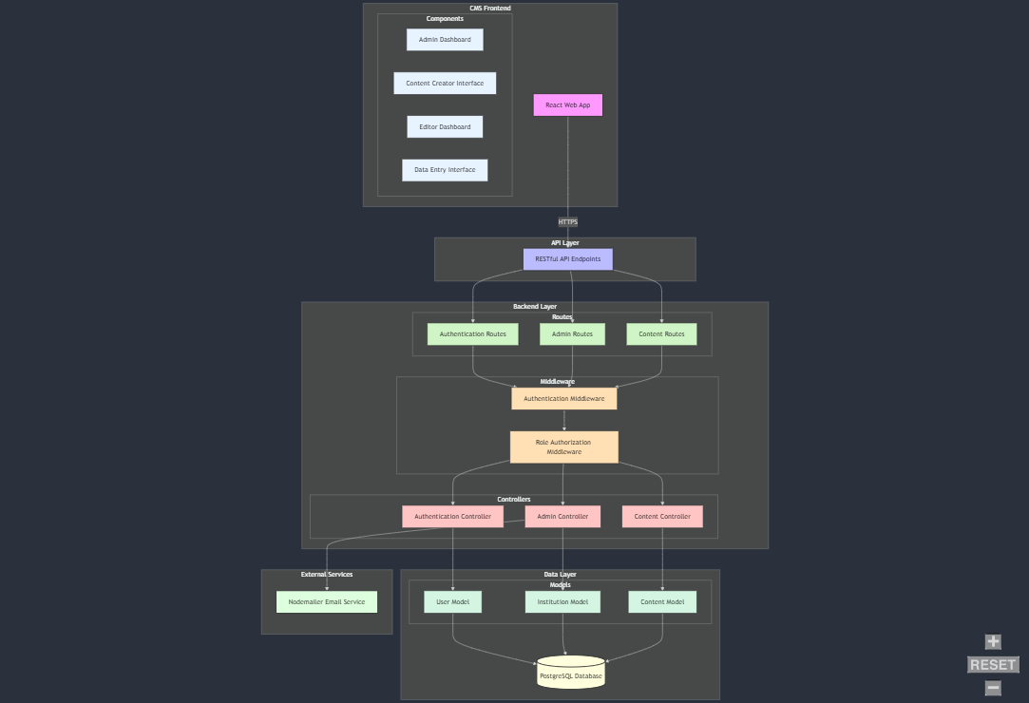
Figure 2. Detailed Architecture Block Diagram

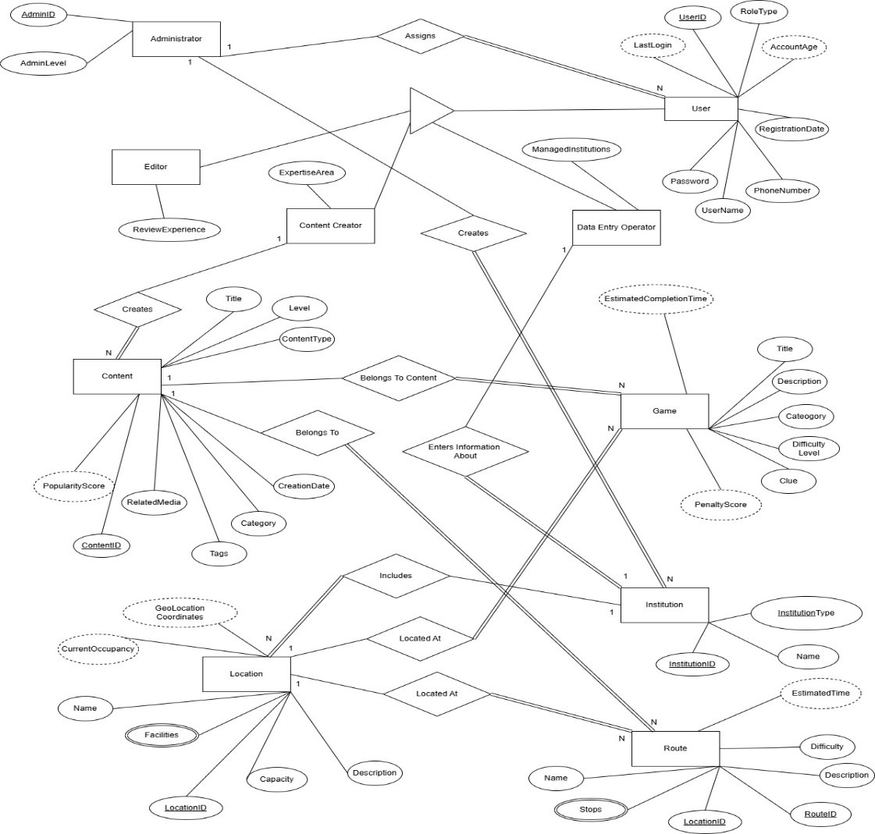
Figure 3. CULTURATI CMS EER Diagram

- Process View
For the 1st Increment Use-Cases, UML Communication diagrams illustrate the interactions between system components, including actors, controllers, and data layers, to achieve the desired functionality. Each diagram is accompanied by an explanation of "Use Case Realization," detailing how the interactions fulfill the corresponding use case requirements.

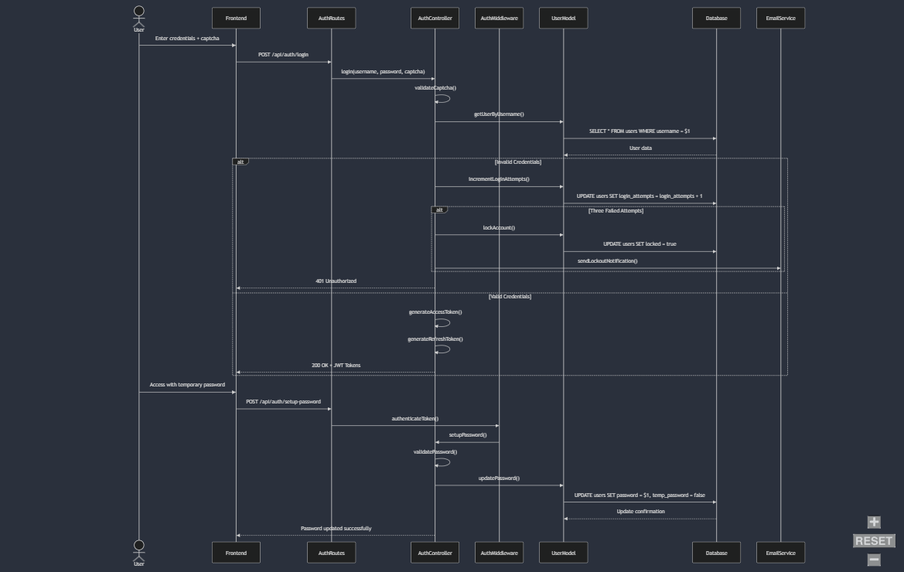
Figure 4. Authentication Communication Sequence Diagram
Authentication Use Cases Realization (UC-01, UC-22) These use cases are realized through the Authentication module, which handles user authentication and first-time password setup:
- Authentication Flow:
  - Client submits credentials through secure HTTPS connection
  - AuthMiddleware validates JWT tokens and user permissions
  - AuthController processes login requests with captcha validation
  - User model performs secure password comparison using bcrypt
  - System generates JWT tokens upon successful authentication
  - Failed attempts are tracked and trigger account locking after three failures
- First-Time Password Setup:
  - System identifies temporary password flag in user account
  - Password setup form enforces security requirements
  - New password is hashed before storage
  - Temporary password flag is cleared upon successful setup

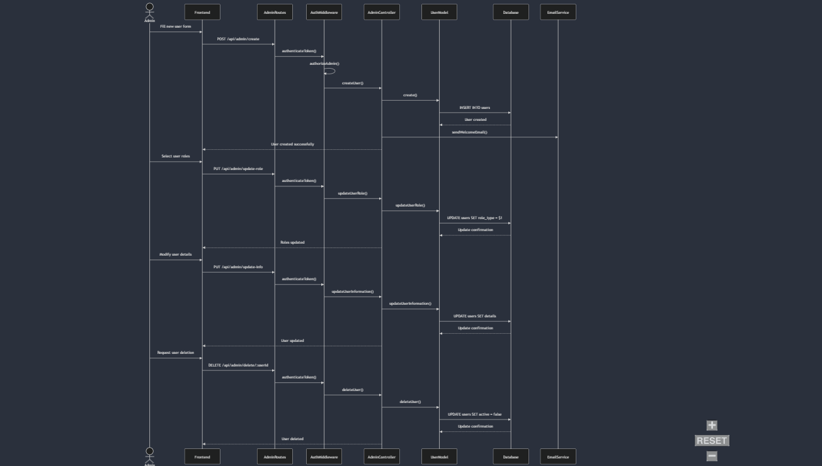
Figure 5. User Management Communication Sequence Diagram
User Management Use Cases Realization (UC-04.x, UC-05) The User Management module implements user administration functionalities:
- User Creation Process:
  - Admin submits new user details through admin dashboard
  - System validates input data and user permissions
  - User model creates database entry with hashed password
  - Email service dispatches welcome message with credentials
  - System logs creation event for audit purposes
- Role Management Process:
  - Admin selects user and modifies role assignments
  - System verifies admin permissions
  - User model updates role associations
  - System maintains role change history
- User Account Modifications:
  - System enforces access controls for user modifications
  - Changes are validated against business rules
  - Database updates are performed atomically
  - Audit logs capture all modifications
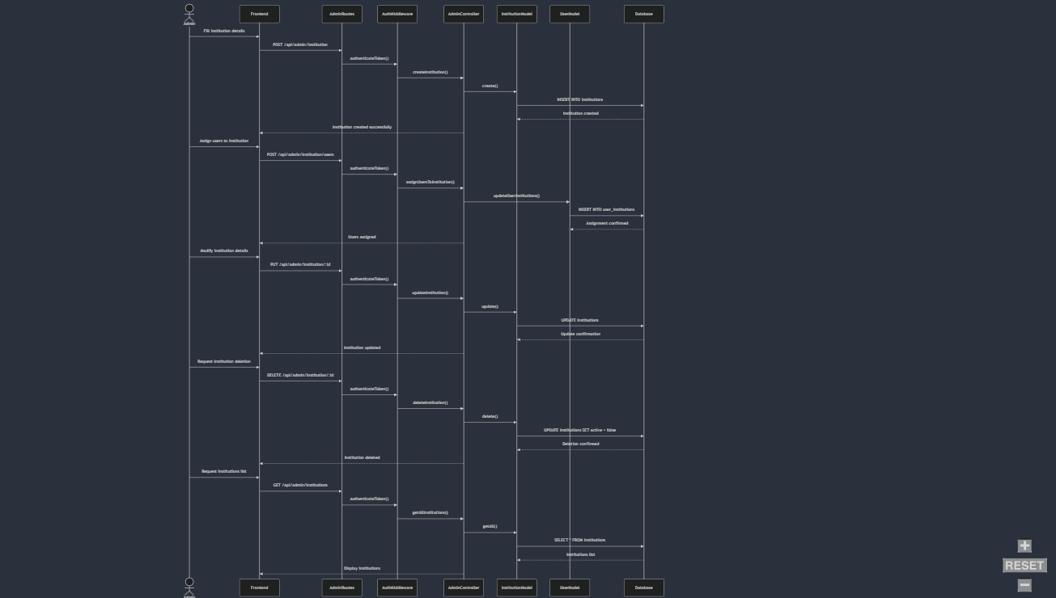
Figure 6. Institution Management Communication Sequence Diagram

Institution Management Use Cases Realization (UC-02.x, UC-03)
Institution management is realized through the following processes:
- Institution Creation:
  - Admin provides institution details through web interface
  - System validates required information
  - Institution model creates new database entry
  - System establishes initial user associations
- User Assignment Process:
  - Admin selects users for institution assignment
  - System validates assignment permissions
  - Database updates reflect user-institution relationships
  - System maintains assignment history
- Institution Maintenance:
  - System provides interfaces for viewing and modifying institutions
  - Changes are validated against business rules
  - Database updates maintain referential integrity
  - System logs all institutional changes

- Physical View
For the Physical View, a UML Deployment Diagram represents the deployment architecture of the software system, illustrating the hardware nodes, software components, and their interactions. This diagram ensures clarity on the distribution of system elements across servers, clients, and other physical devices involved in the first increment.
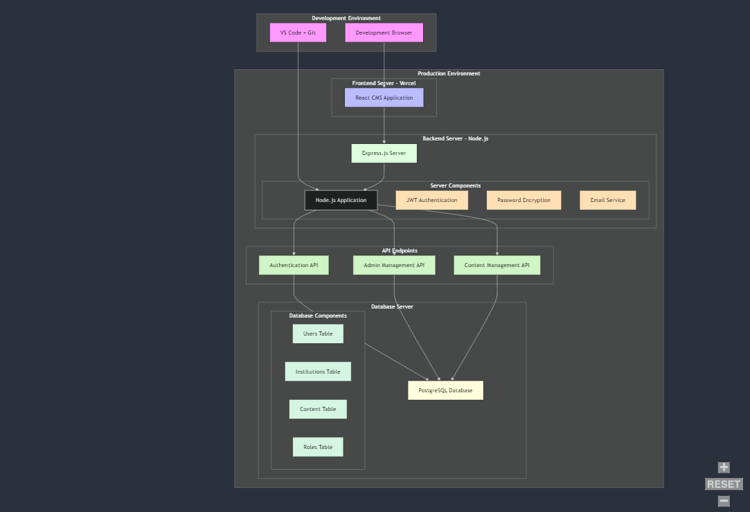
Figure 7. CULTURATI Deployement Diagram

- Design Quality

1. Usability Requirements
- Requirement:
  - The interface must allow average users to complete tasks within 2 minutes without prior training.
  - The admin panel must include tooltips and concise error messages.
- Design Implementation:
  - User-Centric Interface: React.js is used to create a highly responsive, intuitive interface. Forms, menus, and dashboards are role-specific and simplified to minimize complexity.
  - Error Guidance: Input fields have real-time validation with clear error messages and tooltips for guidance.
  - Accessibility: The interface supports accessibility features such as screen readers, adjustable font sizes, and multilingual options.
- Verification and Validation:
  - Usability Testing: Tasks such as content creation and role management are tested with sample users to ensure completion within 2 minutes.
  - Surveys: Feedback on the clarity of tooltips and error messages is collected to refine the user interface.

2. Performance Requirements
- Requirement:
  - Retrieve and display content within 3 seconds under average load conditions.
  - Bulk import/export of 1,000+ records should complete within 10 minutes.
  - The system must handle up to 50 simultaneous users without noticeable degradation.
- Design Implementation:
  - Optimized Backend: Built with Node.js and PostgreSQL, APIs are optimized for fast data access with efficient query designs and indexing.
  - Batch Processing: Import/export processes are handled using optimized database transactions and multithreading for performance.
  - Caching: Frequently accessed data is cached to reduce repeated database queries.
- Verification and Validation:
  - Load Testing: Simulations with tools like Apache JMeter validate the system's response time under different user loads.
  - Stress Testing: Tests bulk operations for import/export under varying dataset sizes and server conditions.
  - Response Time Monitoring: Continuous performance monitoring ensures compliance with the 3-second retrieval benchmark.

3. Software System Attributes
Reliability
- Requirement: Provide 95% uptime, excluding scheduled maintenance.
- Design Implementation:
  - Redundancy: AWS-based infrastructure with failover mechanisms ensures system reliability during server failures.
  - Monitoring: Tools like CloudWatch or ELK Stack provide real-time health checks and alerts.
- Verification and Validation:
  - Downtime Tracking: System uptime is logged and reviewed monthly to ensure compliance with the 95% target.
  - Recovery Testing: Simulates server failures to verify recovery mechanisms and downtime limits.
Availability
- Requirement: Recover from failures within 1 hour.
- Design Implementation:
  - Backup Systems: Automated backups and replication ensure quick restoration of services.
  - Failover Deployment: High-availability configurations (e.g., load balancers and redundant databases) ensure uninterrupted operation.
- Verification and Validation:
  - Recovery Drills: Regularly scheduled drills simulate server crashes to validate recovery time objectives (RTOs).
Security
- Requirement:
  - Sensitive data must be encrypted with AES-256.
  - Strict role-based access control must prevent unauthorized actions.
- Design Implementation:
  - Encryption: All sensitive data is encrypted at rest and in transit (using TLS/HTTPS).
  - Authentication: Multi-factor authentication (MFA) secures user access.
  - RBAC: Backend enforces strict access control, limiting actions based on user roles (e.g., Admin, Content Creator, Editor).
- Verification and Validation:
  - Penetration Testing: Regular security audits and ethical hacking tests validate system defenses.
  - Data Privacy Audits: Ensure compliance with GDPR and encryption standards.
  - Static Code Analysis: Tools like SonarQube identify vulnerabilities in source code.
Maintainability
- Requirement:
  - Modular code must facilitate updates and bug fixes.
  - Documentation must support onboarding of new developers.
- Design Implementation:
  - Modular Architecture: Features are encapsulated into independent modules to simplify updates and debugging.
  - Documentation: Includes API references, UML diagrams, and step-by-step guides for developers.
- Verification and Validation:
  - Code Reviews: Peer-reviewed changes ensure adherence to coding standards.
  - Documentation Audits: Regular checks verify the accuracy and usability of technical documentation.
Portability
- Requirement: The system must be deployable on any OS with Node.js and PostgreSQL.
- Design Implementation:
  - Cross-Platform Design: Built with technologies that are OS-agnostic, such as Node.js and PostgreSQL.
- Verification and Validation:
  - Compatibility Testing: The system is tested on Windows, macOS, and Linux environments.

4. Constraints
- Requirement:
  - Comply with GDPR regulations.
  - Use React.js, TypeScript, and PostgreSQL as mandated by project guidelines.
- Design Implementation:
  - Data Compliance: All personal data is handled securely, with options for users to control their data (e.g., deletion requests).
  - Standard Tools: React.js ensures frontend compatibility, TypeScript enhances maintainability, and PostgreSQL meets database requirements.
- Verification and Validation:
  - GDPR Compliance Audits: Regular audits confirm adherence to privacy laws.
  - Standards Reviews: Ensures that all code is consistent with React, TypeScript, and PostgreSQL best practices.

5. Error Handling
- Requirement:
  - Display clear error messages for user errors.
  - Log invalid data and system errors without crashing.
- Design Implementation:
  - User Feedback: Input fields provide real-time validation and descriptive error messages.
  - Error Logging: All errors are logged with sufficient detail to allow debugging.
  - Fault Tolerance: Non-critical errors are isolated, allowing the system to continue running.
- Verification and Validation:
  - Fault Injection Testing: Simulates user and system errors to verify graceful degradation and error reporting.
  - Error Log Reviews: Validates that logs capture sufficient detail for debugging.

6. Other Non-Functional Requirements
Data Import/Export
- Requirement: Support batch operations for CSV/JSON files.
- Design Implementation:
  - File Parsers: Efficient parsers validate and process bulk data before importing it into the system.
  - Progress Indicators: Users are provided feedback on the progress of import/export tasks.
- Verification and Validation:
  - Batch Testing: Validates processing time and data integrity for 1,000+ record transfers.
Scalability
- Requirement: Scale to support 200 simultaneous users with minimal infrastructure upgrades.
- Design Implementation:
  - Cloud Scalability: AWS Elastic Load Balancer dynamically scales resources based on traffic.
  - Database Optimization: Indexing and connection pooling enable efficient handling of increased traffic.
- Verification and Validation:
  - Scalability Testing: Simulates up to 200 concurrent users to ensure the system performs efficiently.

Low Level Design

Authentication System (UC-01, UC-22)
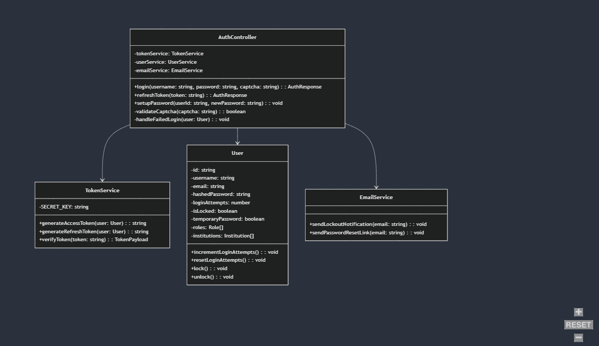
Figure 8. Authentication Class Diagram

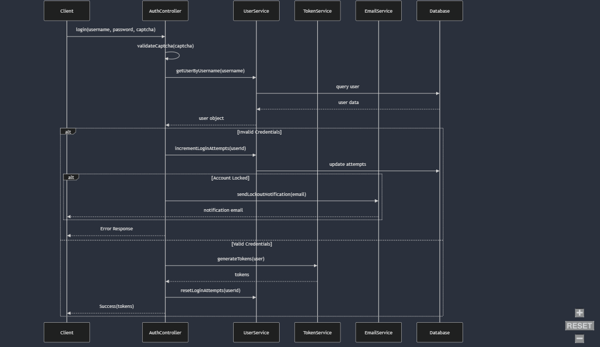
Figure 9. Authentication Sequence Diagram

Authentication Controller Pseudo Code

PROCEDURE authenticateUser(username, password, captcha)
// Validate captcha first
IF NOT isValidCaptcha(captcha) THEN
RETURN Error("Invalid captcha")
END IF

// Get user from database
user = getUserByUsername(username)
IF user IS NULL THEN
RETURN Error("Invalid credentials")
END IF

// Check login attempts
IF user.loginAttempts >= 3 THEN
RETURN Error("Account locked")
END IF

// Verify password
IF NOT verifyPassword(password, user.hashedPassword) THEN
INCREMENT user.loginAttempts
IF user.loginAttempts >= 3 THEN
lockAccount(user.id)
sendLockoutEmail(user.email)
END IF
RETURN Error("Invalid credentials")
END IF

// Reset login attempts on successful login
RESET user.loginAttempts
// Generate tokens
accessToken = generateAccessToken(user)
refreshToken = generateRefreshToken(user)
RETURN Success(accessToken, refreshToken)
END PROCEDURE

First-Time Password Setup Pseudo Code
PROCEDURE setupFirstTimePassword(userId, newPassword, confirmPassword)
// Validate password requirements
IF NOT meetsPasswordRequirements(newPassword) THEN
RETURN Error("Password does not meet requirements")
END IF
IF newPassword != confirmPassword THEN
RETURN Error("Passwords do not match")
END IF

user = getUserById(userId)
IF NOT user.temporaryPassword THEN
RETURN Error("Password already set")
END IF
// Hash new password and update user
hashedPassword = hashPassword(newPassword)
updateUserPassword(userId, hashedPassword)
setTemporaryPasswordFlag(userId, false)
RETURN Success("Password successfully set")
END PROCEDURE

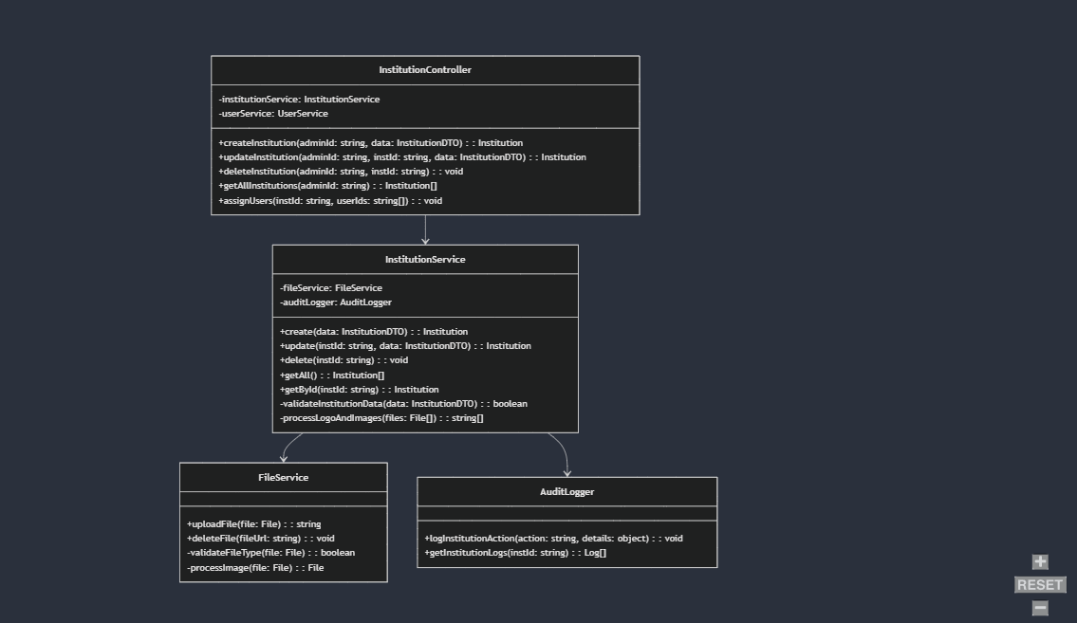
- Institution Management (UC-02, UC-03)
Figure 10. Institution Class Diagram

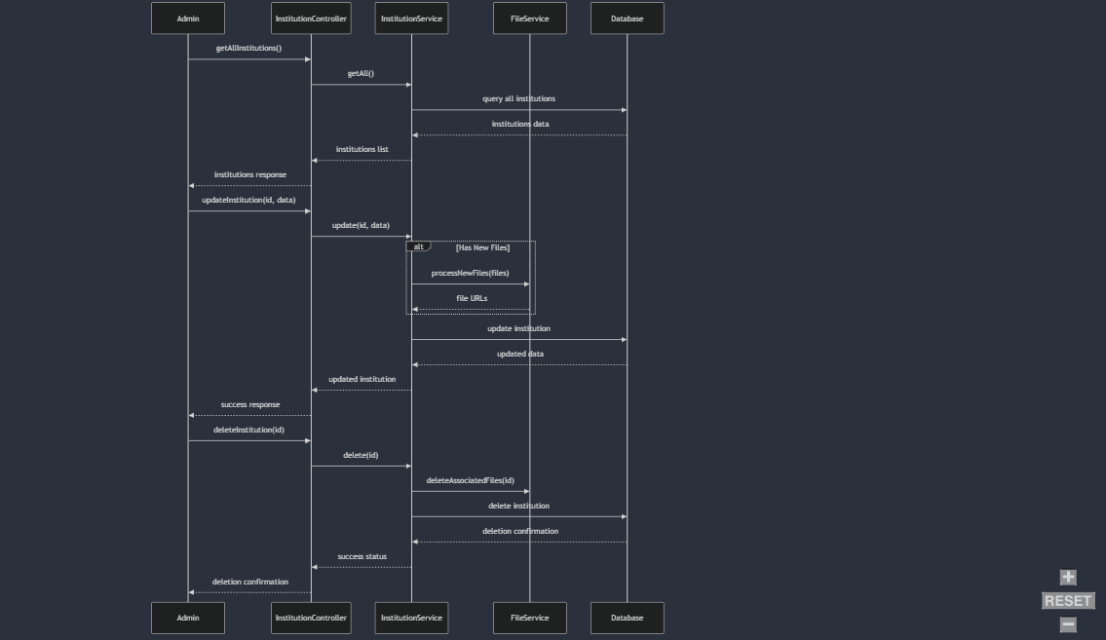
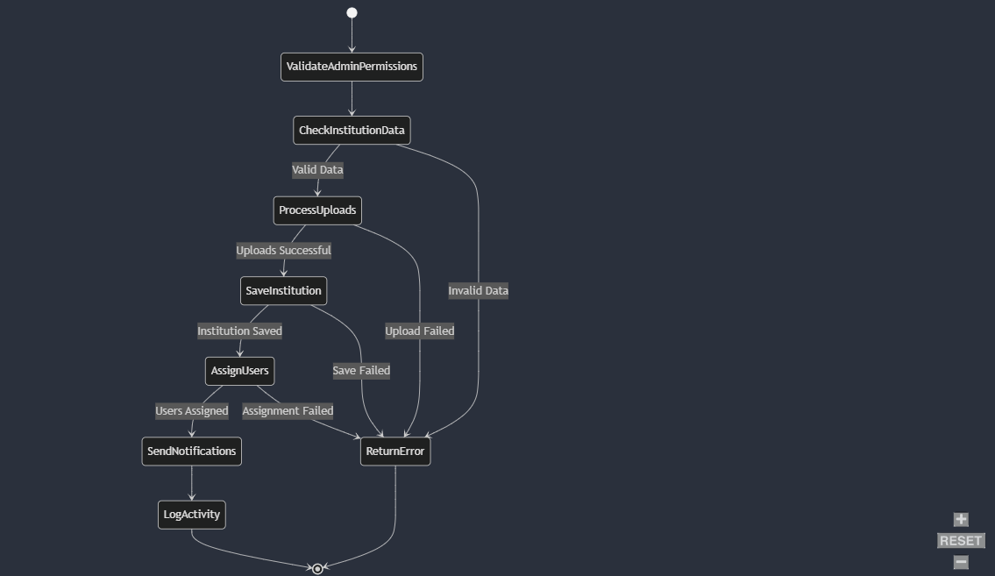
Figure 11. Institution Sequence Diagram
Figure 12. Institution Activity Diagram

Institution CRUD operations Pseudo-Code
PROCEDURE createInstitution(adminId, institutionData)
// Validate required fields
IF NOT validateInstitutionFields(institutionData) THEN
RETURN Error("Missing required fields")
END IF

// Check for duplicate institution code
IF institutionCodeExists(institutionData.code) THEN
RETURN Error("Institution code already exists")
END IF

// Process logo and image uploads
IF institutionData.hasLogo THEN
logoUrl = processLogoUpload(institutionData.logo)
END IF

IF institutionData.hasImage THEN
imageUrl = processImageUpload(institutionData.image)
END IF

// Create institution record
institution = NEW Institution(
name: institutionData.name,
code: institutionData.code,
type: institutionData.type,
logo: logoUrl,
image: imageUrl,
createdBy: adminId
)

saveInstitution(institution)

RETURN Success(institution)
END PROCEDURE
PROCEDURE updateInstitution(adminId, institutionId, updateData)
// Validate admin permissions
IF NOT hasPermission(adminId, "MANAGE_INSTITUTIONS") THEN
RETURN Error("Insufficient permissions")
END IF

// Get existing institution
institution = getInstitutionById(institutionId)
IF institution IS NULL THEN
RETURN Error("Institution not found")
END IF

// Process any new file uploads
IF updateData.hasNewLogo THEN
newLogoUrl = processLogoUpload(updateData.logo)
deleteOldFile(institution.logoUrl)
updateData.logoUrl = newLogoUrl
END IF

IF updateData.hasNewImage THEN
newImageUrl = processImageUpload(updateData.image)
deleteOldFile(institution.imageUrl)
updateData.imageUrl = newImageUrl
END IF

// Update institution record
updatedInstitution = updateInstitutionInDB(institutionId, updateData)

// Log the change
logInstitutionChange(
institutionId: institutionId,
changedBy: adminId,
changes: updateData
)

RETURN Success(updatedInstitution)
END PROCEDURE

PROCEDURE getAllInstitutions(adminId)
// Validate admin permissions
IF NOT hasPermission(adminId, "VIEW_INSTITUTIONS") THEN
RETURN Error("Insufficient permissions")
END IF

// Get institutions created by this admin
institutions = queryInstitutions(createdBy: adminId)

// Format response with necessary data
formattedInstitutions = institutions.map(inst => {
RETURN {
id: inst.id,
name: inst.name,
code: inst.code,
type: inst.type,
userCount: inst.users.length,
logoUrl: inst.logoUrl,
imageUrl: inst.imageUrl
}
})

RETURN Success(formattedInstitutions)
END PROCEDURE

PROCEDURE deleteInstitution(adminId, institutionId)
// Validate admin permissions
IF NOT hasPermission(adminId, "MANAGE_INSTITUTIONS") THEN
RETURN Error("Insufficient permissions")
END IF

// Check if institution exists and was created by this admin
institution = getInstitutionById(institutionId)
IF institution IS NULL OR institution.createdBy != adminId THEN
RETURN Error("Institution not found or access denied")
END IF

// Check for active users
IF institution.hasActiveUsers() THEN
RETURN Error("Cannot delete institution with active users")
END IF

// Delete associated files
deleteFile(institution.logoUrl)
deleteFile(institution.imageUrl)

// Delete institution record
deleteInstitutionFromDB(institutionId)

// Log deletion
logInstitutionDeletion(
institutionId: institutionId,
deletedBy: adminId
)

RETURN Success("Institution deleted successfully")
END PROCEDURE

3. User Management (UC-04, UC-05)

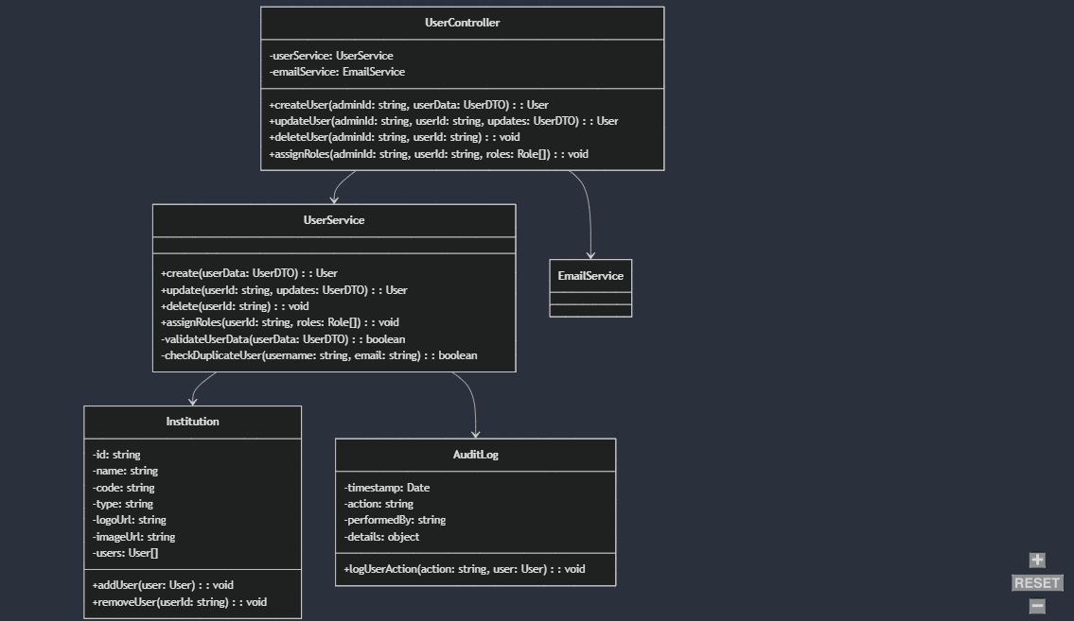
Figure 13. User Management Class Diagram

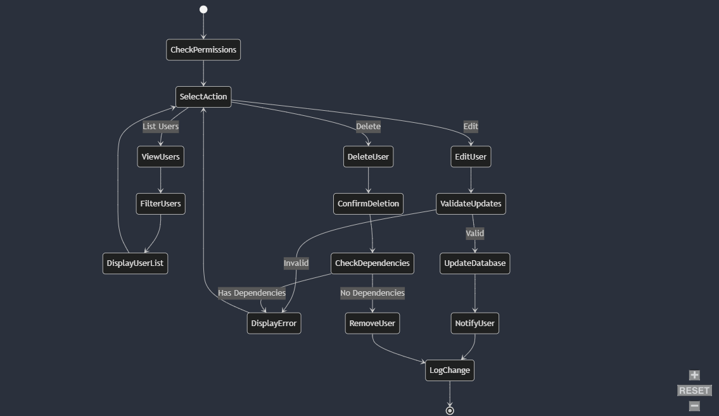
Figure 14. User Management Activity Diagram
User Creation Pseudo Code
PROCEDURE createUser(adminId, userData)
// Validate user data
IF NOT validateUserData(userData) THEN
RETURN Error("Invalid user data")
END IF

// Check for existing username or email
IF userExists(userData.username, userData.email) THEN
RETURN Error("User already exists")
END IF

// Generate temporary password
tempPassword = generateSecurePassword()
hashedPassword = hashPassword(tempPassword)

// Create user record
user = NEW User(
firstName: userData.firstName,
lastName: userData.lastName,
username: userData.username,
email: userData.email,
password: hashedPassword,
roleType: userData.role,
temporaryPassword: true,
managedInstitutions: userData.institutions,
assignedBy: adminId
)

savedUser = saveUser(user)

// Send credentials email
sendWelcomeEmail(
to: userData.email,
username: userData.username,
password: tempPassword
)

RETURN Success(savedUser)
END PROCEDURE

Role Assignment Pseudo Code
PROCEDURE assignUserRoles(adminId, userId, roles)
// Validate admin permissions
IF NOT hasPermission(adminId, "ASSIGN_ROLES") THEN
RETURN Error("Insufficient permissions")
END IF

// Validate roles
IF NOT areValidRoles(roles) THEN
RETURN Error("Invalid roles")
END IF

// Update user roles
user = getUserById(userId)
IF user IS NULL THEN
RETURN Error("User not found")
END IF

user.roles = roles
saveUser(user)

// Log role change
logRoleChange(
userId: userId,
oldRoles: user.previousRoles,
newRoles: roles,
changedBy: adminId
)

RETURN Success("Roles updated successfully")
END PROCEDURE

Discussions

Limitations and Constraints
The preparation of the document collided with the final exams and assignments week; this heavily limited our ability to work on this document with too little time left.

Health and Safety Issues
A lot of anxiety is caused by the collision with the final exams, panicking every group member.

Legal Issues
No legal issues were encountered during the creation of this document.

Economic Issues and Constraints
No economic issues encountered during the preparation of this document.

Sustainability
No sustainability related activity was conducted during the document preparation.

Ethical Issues
No ethical issues encountered during the preparation of this document.

Multidisciplinary Collaboration
No multidisciplinary collaboration was made for preparation of this document.

References

[1] | A. Nizam, T. S. Zafeer, G. Şenkoyun, T. E. Koca and E. Memigüven, "Software Requirement Specifications," 024.
[2] | A. Nizam, T. S. Zafeer, G. Şenkoyun, T. E. Koca and E. Memigüven, "Initial Plan of Team 24," 2024.
[3] | A. Nizam, T. S. Zafeer, G. Şenkoyun, T. E. Koca and E. Memigüven, "Software Project Management Plan of Team 24," 2024.
[4] | A. Nizam, T. S. Zafeer, G. Şenkoyun, T. E. Koca and E. Memigüven, "Software Requirements Specification of Team 24," 2024.

This section provides a brief overview of your SDD, and your major findings and most important things that your Executive, should notice / read. write me an executive symmary for this SDD document, exactly one page 1.5 spacing, 12 font cambria brefly tell what will be done in first, second and third increment, mention some important technologies, summarize this too in executive summarry, make is shorter
ChatGPT promt: this is how the document goes, now give scope and give paragaphs without headings. give more detail, mention block diagram, logical view EER diagram, process view ,physical view
GenAI: GPT4o Prompt: in context to the files in the project [section requirements in the document given] can you answer this part?
GenAI: GPT4o Prompt: using the project context and the codes i provided generate pseudo code that is easily readible for people to understand what we did here.
GenAI: GPT4o Prompt: using the project context and the codes i provided generate pseudo code that is easily readible for people to understand what we did here.
GenAI: GPT4o Prompt: using the project context and the codes i provided generate pseudo code that is easily readable for people to understand what we did here .

